Lab 27 - Configure Local AAA

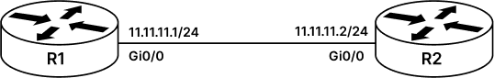

Configure AAA LAB
AAA also stands for Authentication, Authorization and Accounting. It is a widely deployed feature in an enterprise which provides AAA services that handles users request for network resource. Where Authentication is the process to identifying a user or in simple words “Who are you?” and Authorization Is the process of granting or denying network resource or in simple words “What can you do?” and Accounting is the process of keeping a track of user’s activity while accessing the resources or in simple word “What did you do?”.
AAA services can either be “localized” where the devices the user is trying to access itself authenticates, authorizes and can account for users activity. Or it can be “centralized” where the device user wants to access goes to a centralized AAA server which does the authentication, authorization, and accounting for the user. Some examples of AAA servers are Windows Active Directory (AD), Cisco’s Identity Services Engine or more commonly known as Cisco ISE.
AAA server is sometime also referred as RADIUS Server or TACACS+ Server that is purely because of the protocol that is running between Network Access Device(NAD) and the Authentication Engine can either be RADIUS or TACACS+.
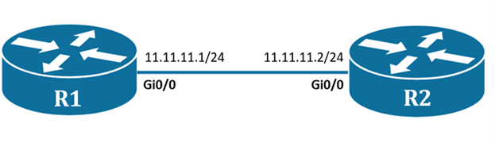
Task 1: Configure IP Address and SSH service on router
Step 1: To start with this lab we will first configure both the routers with relevant IP address.
R1#conf t
R1(config)#int gi0/0
R1(config-if)#ip add 11.11.11.1 255.255.255.0
R1(config-if)#no shutdown

----------------------------------------------------

R2#conf t
R2(config)#int gi0/0
R2(config-if)#ip add 11.11.11.2 255.255.255.0
R2(config-if)#no shutdown
Step 2: Configure R1 router with SSH.
To configure SSH, we will need to configure a valid domain name for R1 router, we will give this domain name as “rst.net” and it will also have a unique hostname in our case “R1”. Once we have prerequisite set for SSH, now we can generate a key pair for SSH using RSA algorithm. When any client tries to access SSH the server, server offers a public key to client using which client encrypts a secret key and sends it to server. Server then decrypts this secret key using its private key and then verify the secret key configured on server, if it matches then it accepts the SSH connection else it rejects.
R1#conf t
R1(config)#hostname R1
R1(config)#ip domain name rst.net
R1(config)#crypto key generate rsa modulus 2048

-----------------------------------------------------
Task 2: Configuration of local AAA on router
Step 1: Now configure local AAA on R1 router with following parameters
username - “admin”
password – “rstforum”
privilege should be – “15”
Privilege levels can be between 0 – 15 total 16 privilege levels, where ‘0’ gives users no privilege, where user only has access of user-mode and can’t really do anything else and whereas 15 is usually full privilege where user can run all and every command that device supports. All the other privilege levels i.e., ‘1-14’ are customizable, where a user with higher privilege can perform all task up to that privilege level as well as all the lower privilege level tasks. For example, user with privilege level 3 can perform all task from privilege level 0 to 3.
R1#conf t
R1(config)#aaa new-model
R1(config)#username admin privilege 15 password rstforum
R1(config)#enable secret rstforum
R1(config)#line vty 0 4
R1(config)#transport input ssh
The above command ‘aaa new-model’ will enable AAA services on router and by default router will go to check its local database to verify the credential/key of the client. The ‘transport input ssh’ command will only permit SSH traffic to enter the VTY port and not any other traffic, by default we permit all kinds of traffic to vty port i.e., Telnet, SSH, etc.,
Step 2: Verify the Local AAA authentication by initiating ssh request from R2 router to R1 router.
R2>en
R2#ssh -l admin 11.11.11.1
password: rstforum

R1>en
password: rstforum
R1#

